**Experiment 4:**

T Raja Aadhithan

602162021

**Write a Perl program that computes the circumference of a circle with a radius of 12.5 units.**

**Code:**

#!/usr/bin/perl

$radius = 12.5;

print "The radius value for the circle is :$radius \n ";

$circumference = (2 * 3.14 * $radius);

print "The circumference of the circle is : $circumference \n";

**Output:**

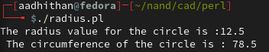

**Write a Perl program to take in two numbers and prints out the result of the two numbers multiplied.**

**Code:**

#!/usr/bin/perl

print "enter number 1 \n";

$n1 = <STDIN>;

print "enter number 2 \n";

$n2 = <STDIN>;

$s = $n1*$n2;

print "answer is $s \n";

**Output:**

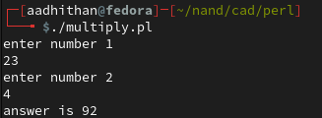

**Write a Perl program that reads in a string and a number, and then prints out the string the number of times requested.**

**Code:**

#!/usr/bin/perl

print "enter number \t";

$n = <STDIN>;

$s = $n**3;

print "cube is  $s \n";

**Output:**

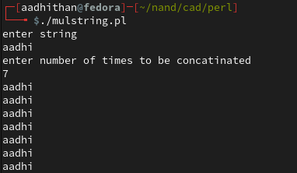

**Write a Perl program that prints the cube of a number.**

**Code:**

#!/usr/bin/perl

print "enter number \t";

$n = <STDIN>;

$s = $n**3;

print "cube is  $s \n";

**Output:**

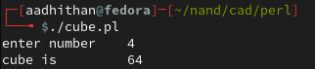

**Write a code to explore String operators.**

**Code:**

!/usr/bin/perl

@s = ('this', 'is', 'the', 'string');

print "original syntax: \n \t";

print "@s \n";

push(@s,'after edit 1');

print "push operation: \n \t";

print "@s \n";

pop(@s);

print "pop operation: \n \t";

print "@s \n";

shift(@s);

print "shift operation: \n \t";

print "@s \n";

unshift(@s, 'this');

print "unshift operation: \n \t";

print "@s \n";

**Output:**

